Numpy

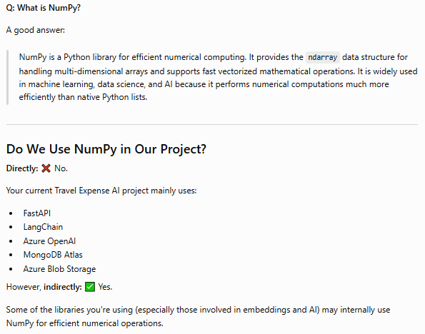
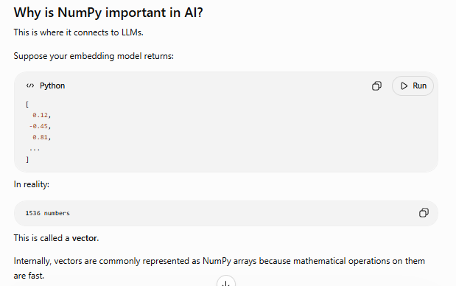
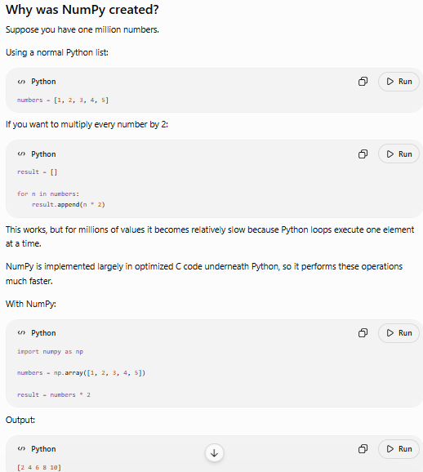
Pandas
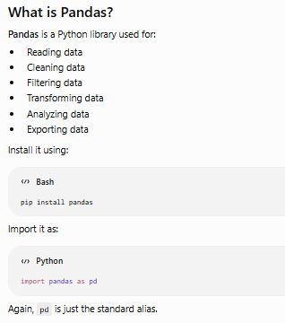
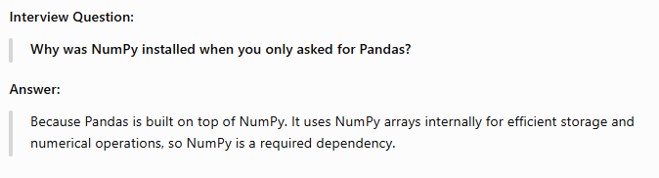
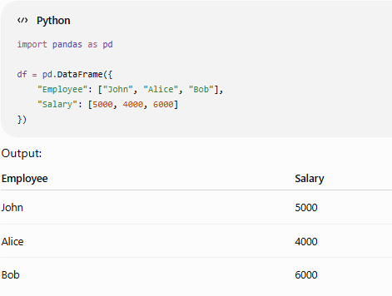

What is a DataFrame?
A DataFrame is a 2-dimensional table with:
- Rows
- Columns
- Column names
- Different data types in different columns
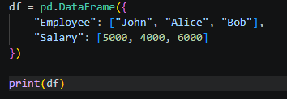
Output:
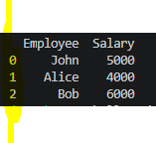
Notice the numbers on the left (0, 1, 2) are the index (row labels).
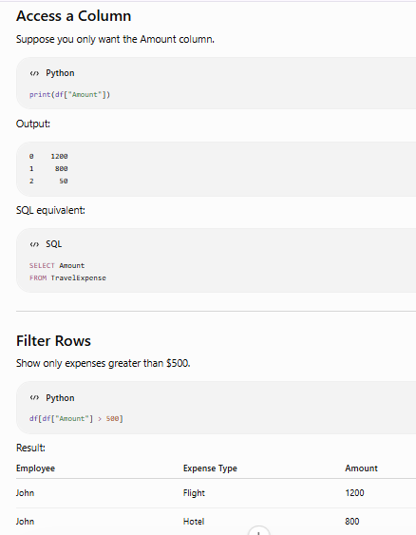

• • scikit-learn (basic ML)
• PyTorch (deep learning fundamentals)
• Transformers (Hugging Face)
• LangChain (LLM orchestration)

